Design Outline:

My plan was to have one input function that collects all the user inputs and then a main function which calculates the total costs from the returned variables of the inputs function. The inputs function will have to ask the user for a gas and food cost entry for every day of the trip. It will also have to make sure the user only enters viable values, so float and int values only.

Test plan:

1: Required case of 5 days and 5 people.

2: User enters invalid inputs which the program recognizes and asks for corrections.

3: Program outputs correct values rounding to cents and works with any amount of days

1:

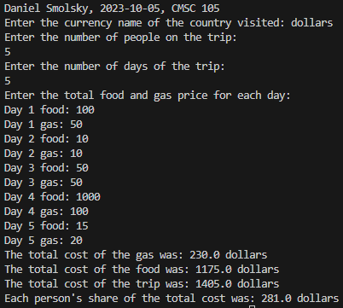

2:

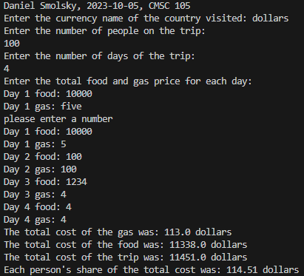

3:

